**2024 U.S. Energy Employment Report**

**Social Media Toolkit**

The U.S. Department of Energy (DOE) released the 2024 U.S. Energy and Employment Report (USEER) — a comprehensive study designed to track and understand employment trends within key energy technologies. As the private sector continues to announce major investments in American-made energy thanks in large part to [President Biden’s Investing in America agenda](https://www.whitehouse.gov/invest/?utm_source=invest.gov), the 2024 USEER show us that clean energy jobs grew at twice the rate as already solid job growth job growth in the overall economy, unionization rates surpassed the traditional energy sector for the first time and employers reported less difficulty hiring qualified workers.

**Our main takeaways:**

1. Jobs in clean energy grew by 4.9%, more than twice as much as the already-robust job growth rate of 2.0% in the overall economy.
2. For the first time ever, unionization rates in clean energy, at 12.4%, surpassed the rate in traditional energy employment of 11% - both sectors far surpassing unionization in the private sector at 7%.
3. Unionized employers reported less difficulty hiring than non-union employers, yet both reported an easier time hiring workers in the energy sector than last year.
4. 2024 USEER findings show growth in every state and significant growth in clean energy sectors crucial to helping the U.S. achieve 100 percent clean energy goals.
5. This year, in addition to the 90,000 traditionally counted energy construction jobs, the report found an additional 28,000 jobs in 2023 carrying out the work of building new clean energy factories, ports, and warehouses to make, store, and transport clean energy products.

**Help spread the word! As an advocate for good-paying, high-quality clean energy jobs, please utilize this toolkit to amplify the report to your network.**

* **Join the conversation**
  + Tag @ENERGY and @SecGranholm in your posts.
* **Resources**
  + U.S. Energy and Employment Report [link]
  + Press release [link]
* **Recommended Hashtags** 
  + #USEER and #2024USEER
  + #CleanEnergyStrong
  + #CleanEnergyWorkforce
  + #IRAatWork

**⚡ Sample Social Posts**

|  |
| --- |
| **Post 1**  Today, @ENERGY reported the latest jobs trends in the U.S. energy sector.  Among the findings:  🔋 Clean energy jobs grew at more than 2x the rate of U.S employment  👷👷‍♀️‍ Energy workforce added over 250,000 jobs in 2023  ⚡️️🔌 Energy sector job growth in technologies crucial to the U.S. reaching #100PercentCleanEnergy goals  Read the full report - https://www.energy.gov/policy/us-energy-employment -jobs-report-useer |
| **Post 2**  🔋☀️🔌 The Biden Harris clean energy agenda is driving a strong energy economy & workforce.  #2024USEER reports clean energy is driving growth in the energy sector, with jobs in clean energy growing by 4.9%, more than twice as much as the already-robust job growth rate of 2.0% in overall economy.  https://www.energy.gov/policy/us-energy-employment -jobs-report-useer |
| **Post 3**  ✊ ⚒️👷👷‍♀️‍ For the first time ever, unionization rates in clean energy, at 12.4%, have surpassed the rate in traditional energy employment of 11%. This is driven by rapid growth in strongly unionized construction activity.  The #2024USEER shows historically high unionization rates across the clean energy sector, thanks to the Biden-Harris agenda to build the clean energy economy with good-paying, high-quality union jobs.  https://www.energy.gov/policy/us-energy-employment -jobs-report-useer |
| **Post 4**  Clean energy jobs are on the rise! In 2023, the US added 250,000 jobs in energy, with clean energy employment accounting for more than half of new energy sector jobs.  ⚡️🔋☀️🔌 5% of all new jobs created from 2023-2024 in U.S. economy were in the clean energy sector!  https://www.energy.gov/policy/us-energy-employment -jobs-report-useer |
| **Post 5**  According to the #2024USEER, the energy industry sectors experiencing the highest job growth from 2022 to 2023 were utilities and construction.  ⚡️ Utilities sector saw the fastest employment growth of 5.0% in 2023, adding nearly 30,000 jobs.  🏗️ Construction sector added nearly 90,000 energy jobs, growing 4.5%, almost double the economy-wide construction employment growth of 2.3%.  Read full report here: https://www.energy.gov/policy/us-energy-employment -jobs-report-useer |

**⚡ Graphics:**

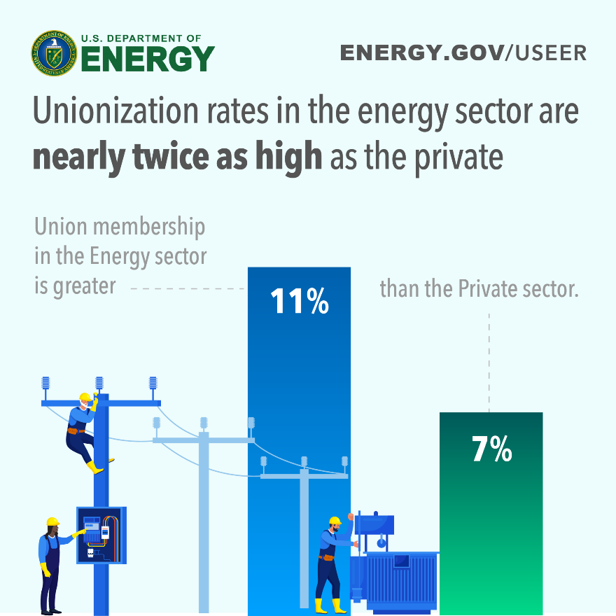

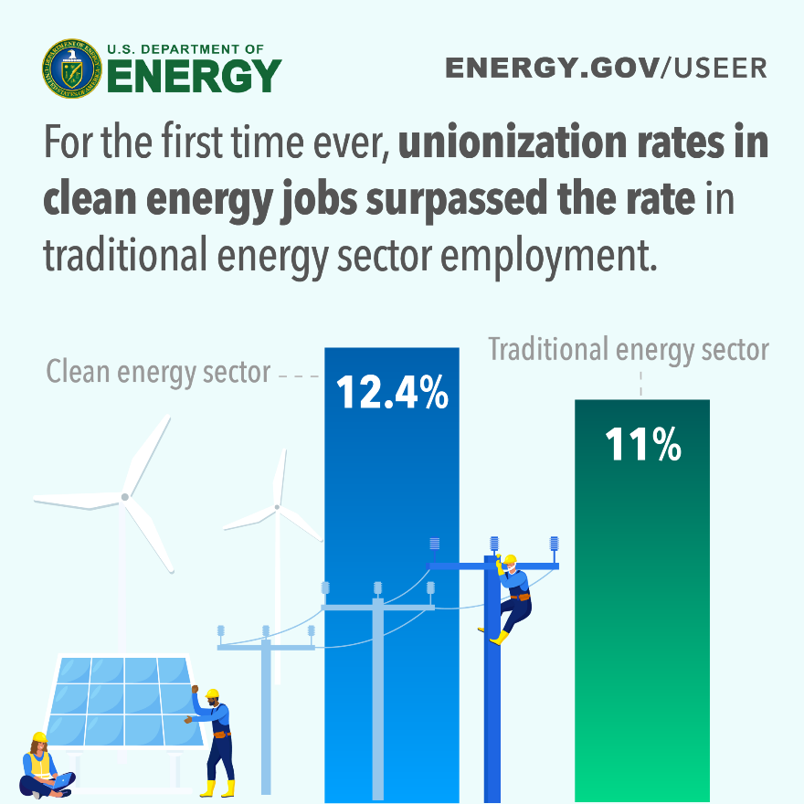

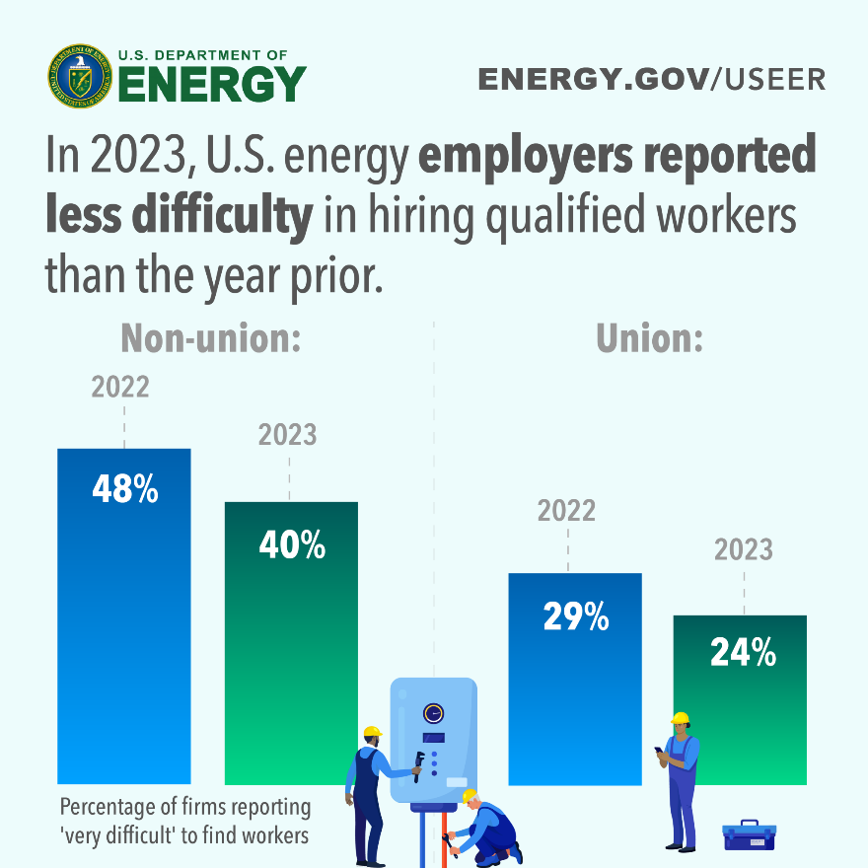

**⚡ Twitter/X Sample Posts**

|  |
| --- |
| **Post 1**  Today, @ENERGY reported the latest jobs trends in the U.S. energy sector.  Among the findings:  ⚡️ Energy jobs grew at more than 2x the rate of U.S. employment  🔋 Clean energy jobs grew in every state  👷‍⚒️👷‍♀️ Energy workforce added over 250,000 jobs  https://www.energy.gov/policy/us-energy-employment -jobs-report-useer |
| **Post 2**  Clean Energy is driving a strong energy economy & workforce. 2024 USEER findings show significant growth in energy sectors crucial to helping the U.S. achieve #100PercentCleanEnergy goals.  🚘🔋🔌**⚡**☀️  Read full report: https://www.energy.gov/policy/us-energy-employment -jobs-report-useer |
| **Post 3**  For the first time ever unionization rates in clean energy, at 12.4%, surpassed the rate in traditional energy employment of 11%, driven by rapid growth in unionized construction and utility industries.  Read full report: https://www.energy.gov/policy/us-energy-employment -jobs-report-useer |
| **Post 4**  Motor vehicle jobs are growing, and the most rapid growth is in zero-emission vehicles. In 2023, jobs in motor vehicles grew, with clean vehicle employment increasing 11.4%, adding 24,826 jobs. 🚘🔋🔌**⚡**  Read full report: https://www.energy.gov/policy/us-energy-employment -jobs-report-useer |

**⚡Facebook + Linkedin Sample Posts**

|  |
| --- |
| **Post 1**  In 2023, jobs in clean energy grew at more than twice the rate of the strong overall U.S. job market. Clean energy jobs grew at double the rate of job growth in the rest of the economy, adding 149,000 new jobs.  Read full report here: https://www.energy.gov/policy/us-energy-employment -jobs-report-useer |
| **Post 2**  Clean Energy is driving a strong energy economy & workforce. 2024 USEER findings show significant growth in energy sectors crucial to helping the U.S. achieve #100PercentCleanEnergy goals.  Read full report here: https://www.energy.gov/policy/us-energy-employment -jobs-report-useer |
| **Post 3**  The energy sector added more than 250,000 jobs, increasing from 8.1 million total energy jobs in 2022 to nearly 8.4 million in 2023. The Biden-Harris Investing in America agenda is driving clean energy investments and prioritizing good paying, high quality jobs!  Read full report: https://www.energy.gov/policy/us-energy-employment -jobs-report-useer |
| **Post 4**  ✊ ⚒️👷👷‍ For the first time ever, unionization rates in clean energy, at 12.4%, have surpassed the rate in traditional energy employment of 11%. This is driven by rapid growth in strongly unionized construction activity.  The 2024 USEER shows historically high unionization rates across the clean energy sector, with every state in the country showing rapid growth in renewable energy, nuclear, and energy efficiency jobs.  Read full report here: https://www.energy.gov/policy/us-energy-employment -jobs-report-useer |