This checklist lays out three distinct phases to transitioning your fleet vehicles to ZEVs: Plan, Design, and Execute. There are multiple goals and several actions to take within each phase. The phases serve as a general chronological guide, but may take place in a different order than laid out below. Please use this checklist to ensure that you continue along the path to fleet electrification and you are ready to receive and operate ZEVs.
PHASE | GOAL | ACTION | COMPLETION DATE | PARTIES INVOLVED
PLAN |   Train Team | ☐ Review EV knowledge and training materials.
 |   Identify ZEV  & EVSE Opportunities | ☐ Complete the ZPAC tool to identify priority ZEVs and EVSE sites.
 |  | ☐ Complete the DOE EVSE Planning Form to inform collaboration, site design, and project management. Consult the report on EVSE site assessments for Army facilities for an overview of EVSE options.
DESIGN |   Meet with Key Stakeholders & Design EVSE | ☐ Engage with priority site staff, including energy manager, fleet manager, site leadership, and facility owner (PBS if GSA-owned).
 |  | ☐ Contact the local electric utility (EV U-Finder).
 |  | ☐ Work with leadership to secure funding and leverage other projects or sources (e.g., ESPCs).
 |  | ☐ Determine installer (in-house or contractor).
EXECUTE | 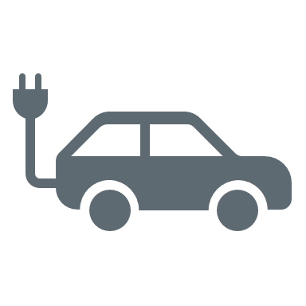      Acquire EVs & Install EVSE | ☐ Acquire EVSE from GSA’s EVSE BPA or GSA Advantage.
 |  | ☐ Lease or purchase ZEVs from the GSA AFV Guide.
 |  | ☐ Install EVSE and set up accounts for networked chargers.
 |  | ☐ As EVs begin operation, support drivers with resources such as the Alternative Fuels Data Center and Station Locator to identify publicly available charging stations.

