Dear Secretary Granholm & Director Coe,

Here is the Utah EMP Task Force’s response to your wise RFI on securing our grid.

**Hardening the US Electrical Power Grid**

Utah EMP Task Force, June 2021

**BLUF\***: The Utah EMP Task Force would like to see the Federal government direct or partner with public utilities and State Agencies to prepare our electrical power infrastructure to withstand powerful solar storms or a man-made nuclear or conventional EMP (Electromagnetic Pulse) attack as soon as possible. We recommend doing this through State and/or Federal Agency coordination and oversight.

Key considerations:

* Texas is considering model Legislation, SB-1606 to Harden the Texas power grid against all hazards. It’s an excellent example to work from: <https://capitol.texas.gov/BillLookup/Text.aspx?LegSess=87R&Bill=SB1606>
* This is a true bipartisan issue reflecting the correct interpretation of the US Constitution Article I, Section 8 “*Congress shall have the power to...provide for the common Defence and general Welfare of the United States…”*
* The Utah House & Senate *unanimously* passed HJR014 in 2019 calling for the US and Utah to harden their power grids:  
  <https://le.utah.gov/~2019/bills/static/HJR014.html>

Besides protecting the core of the grid, a useful plan must include protection of associated communications, monitoring devices and controlling computers. The standard of protection must exceed a 100,000 volts/meter impact, and ideally accord with or exceed classified DoD standards. The standards laid out in the Texas Senate Bill are an acceptable minimum, unless the US Military recommends higher. The DoD has testing facilities and data not easily obtainable by other agencies or persons.

What follows is an expanded discussion of the topic in white paper format covering: (1) Threats to the power grid, (2) Protective measures (3) Choosing a Department or Agency to oversee plan creation and subsequent execution, (4) Funding options, (5) Obstacles to HTG (Hardening The Grid) and (6) History.

*\*BLUF is a military acronym for “Bottom Line Up Front” giving leaders a quick snapshot of the topic and recommended course(s) of action.*

1. **The Threats.**

● **Solar Flares/CMEs**: There are several threats that could interrupt or destroy Utah’s portion of the Western Power Grid Chief among these are solar flares or Coronal Mass Ejections (CMEs) which are expected during the active phase of the 11-year solar cycle which begins ~2023. Affects large areas and has hit North America significantly in 1989, 1921 and especially in 1859. Just in 2021 European researchers discovered evidence of a massive, 3 day solar storm that turned the skies over Europe red and would have melted modern day transformers.

● **Nuclear EMP Weapons**: Specially modified nuclear weapons designed to optimize the Electro-Magnetic Pulse (EMP) effect that all nuclear weapons have. These are effective over a very wide, line-of-sight area and are sometimes called Super EMP weapons. Russia, China and North Korea have these capabilities.

● **General Nuclear Weapons**: All nuclear weapons produce a very powerful EMP field (effect) over a large area, when detonated above earth's atmosphere. The higher the detonation, the larger the area affected. This will destroy unprotected electronics large and small. Virtually anything over 18” will have its electronics physically destroyed, including unshielded underground electronics.

● **Conventional EMP Weapons**: These can be drone delivered pulses or ground detonated devices affecting a small area (a few city blocks) or larger aircraft delivered EMP bombs designed to EMP strike a city or similar sized area.

● **Cyber threats (hacking), physical threats (small arms/artillery), weather threats (including earthquakes) and other means of sabotage.**

The most severe problems with EMP weapons are their total destruction of all parts of the electrical system including appliances, computers, wires, transformers and circuitry. The US military is well aware of this threat. Russia, China, Israel, North and South Korea and South Africa all have hardened their electrical grids against an EMP attack, yet in the US only key parts of the US military and select government installations have hardened equipment. Without protection, US war planners understand the US is extremely vulnerable.

Large transformers (~300 in Utah, 3,000+ in the US) are custom built and can take 12-18 months to build. While some of these are still made in the US, we are now mostly dependent on other friendly countries to export them to us including Mexico, Germany and South Korea. While China is willing to sell transformers, prudence dictates not buying from a potential adversary who may install backdoors to allow easy hacking or induced malfunctions in time of war or tension. While other countries make transformers, they will not all sell them. An EMP or Solar flare/storm will physically destroy (burn and melt) these transformers in 1-90 seconds. In March of 1989 a solar event caused a large transformer in Montreal to burn up in about 90 seconds.

Large transformers represent our greatest vulnerability and longest time to replace if an EMP or solar flare destroys more than 2-3% of those, based on utility spare stocks. They are very heavy and difficult to transport. Substations will sometimes house more than 1 large transformer.

We have a 2020 detailed cost estimate by the Foundation for Resilient Societies, it appears that to protect an entire substation from solar storms, EMP and local physical threats (i.e., a wall) would cost approximately $150,000 per substation. Existing utility construction funds or a small user fee could be used to fund this critical hardening and physical protection, which would also protect against hacking. Idaho National Laboratory suggests a large transformer might be protected for $75,000 or less if done on a large scale basis.

<https://www.resilientsocieties.org/threats.html>

To protect the most population the fastest, hardening power plants and substations along the most populated areas as well as those areas with critical DoD assets, would be the wisest, most cost effective way to begin this effort and then spread out to all areas to provide for the common defense and general welfare of all US citizens. The threat to public safety if the grid goes down for a prolonged period cannot be overemphasized. The brief loss of the Texas power grid in February of 2021 and concomitant loss of life underscores the critical need for continuous power in modern life.

1. **Protective Measures.**

Considering how our electricity is produced and distributed; every step along the grid network has vulnerabilities and needs protection to continue to function if there is a solar storm or EMP/nuclear attack. US DoD & DOE as well as Soviet K-testing in 1961-1962 showed that electrical production facilities, transformers and power distribution lines all need protection like: **Shielding, Faraday cages or air gap circuit breakers** to ensure they are not destroyed when overloaded by the extremely high voltage of solar storms or EMPs. The electrical impact of targeted EMP weapons (conventional or nuclear) can be expected to impact US targets at 30K – 200K Volts per square meter, with 30K – 100K being in the more normal realm and 200K Volts/sq. Meter from optimized or Super EMP weapons.

Production facilities and transformers (especially the big ones like Extra High Voltage transformers) require protection because they take years (12-18 months) to build. Some shielded (during storage) spare transformers, wires and components are also needed.

The critical small computers that control things like natural gas or other fuel lines and electrical flow also require protection. This can be accomplished a number of ways, the small computers are called “**SCADA**”, Supervisory Control And Data Acquisition systems. Local Utah companies have the ability to protect communication centers and SCADAs and have already done such work for the Federal Government, which is increasingly, quietly, protecting itself now beyond the nuclear Triad. Federal agencies are spending to protect their operations from an EMP or solar storms and Utah companies are part of this effort, their knowledge of exactly what to do to protect communications and computers is critical and a benefit to Utah.

Government and utility control and communications facilities also require special EMP shielding to continue operations after a solar or EMP event. Military Departments and the DHS are familiar with how to protect such assets and there are Utah companies like Conductive Composites and others that manufacture and install protective devices and shielding to get this accomplished in a timely fashion.

It would also be wise to add physical protection (hardened walls) to power substations and other critical infrastructure a Utah committee or agency charged with doing this work identifies. Ballisticrete, for example, is a new very hard concrete that can be applied over existing walls to harden them from up to 50 caliber rounds, for example.

Electrical substations have been attacked directly in the US by small arms fire. Most are not protected by anything more than a fence. Dixie Power in Southern Utah does have walls around their substations already which protects against fires, wind, and direct attack with small arms and other similar threats (grenades, larger calibers, and partially against artillery). Hardening for an EMP also protects against hacking attacks.

1. **Tasked Department Oversight & Technical Advisors**

Hardening the power grid for a State or the Nation is a large, long-term (2-5 year) effort, and requirements could be updated during that time due to advances by potential adversaries. To attempt to specify all needed actions in one bill from the Legislature would be difficult.

1. **Funding Options**

The good news of hardening the grid is it’s relatively inexpensive insurance for a very critical piece of infrastructure. A “Grid Security” fee of even 50 cents or $1/mo per electric customer would allow significant progress over 3-5 years.

Electric utilities also have their own existing construction funds, which are allowed to be more profitable than their regular operations. The Government could direct them to use those funds over time to harden the power grid and associated SCADA, monitoring and communications devices.

Another funding approach would be taking just a portion of the current surcredit being issued to electric customers (which most have not even noticed), say 40-50% of the amount of the surcredit, which is ~3% of an electric bill would easily fund grid hardening while still keeping the cost of electricity lower than before these 2017 tax cuts went into effect. Allowing electric utilities to use construction and/or general funds might speed up completion since they already have significant funds on hand. DoD funds might also be considered separately for hardening of military and key industrial components.

Democratic proponents may especially like the Union work and infrastructure upgrade that a national effort like hardening the power grid would entail, while Republicans could be expected to favor the added defense and infrastructure benefits. Hardening the grid against all threats (to include space weather and EMPs) definitely benefits a mix of US citizens, commercial, and defense interests.

1. **Obstacles.**

It’s common for people and institutions to resist change, even good change. However, our potential adversaries (China, Russia, Iran, North Korea and possibly others) are delighted with our failure to harden our grid which leaves us incredibly vulnerable.

As a trained, professional, USAF war planner, I can tell you our lack of a hardened power grid is a glaring omission other war planners would be keen to exploit. I think it is probably our greatest vulnerability. Potential adversary national planners understand how disinformation, confusion and political or corporate lobbying efforts and influence can keep us from what we really must do. There’s also the problem of the easiest thing to get: Bad Information.

The US and other militaries who can test nuclear and other weapons and have EMP generators for testing have the best information/intelligence on nuclear and conventional EMP testing; however, much of that remains classified at various levels and not available to even other Government agencies. This sets the stage for confusion.

This leaves agencies like **EPRI** (Electric Power Research Institute) at a disadvantage when giving guidance to utilities, and unfortunately, probably because of the information they don’t have, or possibly from hidden adversary influence, they have severely downplayed the EMP and solar threats. It’s important to rely on the best information available, and that is from military or other classified government research.

EPRI has given overly-optimistic guidance to utilities. Is this because of ignorance; subterfuge or influence from adversaries? It’s very hard to say; but they have glossed over the threat that the US Military and other countries clearly realize. EPRIs guidance amounts to a disinformation campaign and needs to be ignored unless and until they avail themselves of EMP testing and publish updated guidance.

Realize there is a reason Russia, China, North Korea and Iran are perfecting Super EMP weapons: It’s not to destroy our iPads or refrigerators, but to take down our electrical grid which supplies 99% of military needs leaving the US practically defenseless and neutralizing our power in under an hour and our citizens without power for an extended period.

1. **History**.

It’s important to remember that EMP effects or geomagnetic storms (CMEs and solar flares, or solar storms) have impacted the world before, and North America in particular has had 3 significant solar storms impact us since 1859, with other narrow misses.

In 1859 the “Carrington Event” released massive amounts of energy into the earth’s high atmosphere, super charging it. Northern lights were visible as far south as the equator and produced enough light to read print at night. The railroad lines of the day absorbed this energy and actually twisted, and the fledgling telegraph system was overloaded with electricity it absorbed and distributed, including right back into some personnel operating telegraphs. In 1921, the so-called Railroad Storm struck North America and damaged railroads and the electrical devices (like signals and switches) that ran them. If we had more electrical infrastructure, we would have had more damage. When the sun produces solar storms, the energy we receive affects only longer structures, like railroads or power lines; not so with an EMP. Military testing (unclassified) demonstrates that energy from an EMP damages much smaller devices, down to about 18”. Smaller devices are too small to get the full 18” wavelength and so are unaffected (cell phones for example are not affected).

In March 1989 a solar storm actually did take down the Quebec power grid in Canada by burning up a large transformer. The electric utility did not have the time to react; they went from operating to shut down because of transformer damage in 92 seconds.

It is extremely rare that a utility will have an in-place spare transformer ready to connect. Fortunately, Hydro Quebec did have that spare or else they could have lost power for weeks or months. Our utilities have some spares, but only enough to cover sporadic infrequent transformer damage; not damage to large areas of a power grid. The large transformers are not made in North America anymore, and often take over a year to build. Worldwide production of Extra-High Voltage (EHV) Transformers is less than 200 per year, the US has over 3,000 of these to protect.Transformers were also damaged in MA & NJ and had to be replaced, this was our warning shot. In July of 2012 a massive extreme solar storm missed the earth by 3 days. This was the most powerful solar storm in over 150 years, and had it hit 3 days earlier, Earth would have been squarely in the bullseye and sustained major damage to electrical equipment wherever it impacted. It would have been devastating; that was another reminder from Solar cycle 24, we have just now (fall of 2020) entered the active phase of Solar Cycle 25 and we can expect more of these events, peaking in 2025 due to the 11 year solar cycle NASA has identified.

History shows the impact of solar storms, which are far less damaging than energy from EMP weapons. It has happened before, we will be impacted again, and we can only deal with the most modest solar storms and we are totally, unequivocally unprepared for an EMP attack whether conventional or nuclear, and anyone that tells you otherwise is misinformed.

The Legislative history of hardening the Grid is frustrating. In 2010 the US House unanimously passed the GRID Act which would have fixed the issue for about $3B; but the Senate Energy committee gutted it and replaced hardening the grid with clean energy tax credit legislation deemed more friendly to then President Obama. Ideally, this would be handled at the Federal level, but there are forces determined to not allow that to happen, so States must act.

Several States (TX, FL, AZ, CA and ME) have a similar history of one body unanimously passing Legislation, only to see their peers in the other Legislative body undo the effort, usually in Committee. Maine actually did pass Legislation, but utilities declared it unworkable because it lacked the standards and technical guidance they maintained they needed. These efforts are documented in Dr. Peter Pry’s book: *Blackout Wars*, available on Kindle for $2.99 and an excellent primer on the threat and solution posed by solar or nuclear impacts.

So far only the US nuclear Triad is hardened, including the Pentagon and White House and some critical military C4I (Command, Control, Communications, Computers and Intelligence) facilities have been hardened to the HEMP (High altitude Electromagnetic Pulse) standards established in DoD MIL-STD-188-125-1 published in July 1998 and still in use currently (2021). That military publication is unclassified and the Utah EMP Task Force has a PDF version of this available to anyone who desires a copy. Military recommendations to harden components of infrastructure to withstand at least 50,000 volts/meter (50KV/m) may be **outdated** because of new optimized nuclear weapons or “Super EMP” weapons designed to produce 200KV/m impact.

The Utah EMP Task Force recommends a 100-150KV/m hardening standard.

Disinformation and/or influence campaigns to ensure we do not protect ourselves should be expected and ignored, military testing has verified the threat, though the military is not known for sharing test data widely, especially when there is classified test data.

EMP testing is available locally at the Little Mountain facility in Weber County and the Legislature should consider an appropriation for some testing which is reasonably affordable. The EMP Task Force can assist to coordinate testing as needed.

Thank you for your earnest consideration of this serious existential threat that must be prepared for before the sun or an adversary exploits our vulnerability.

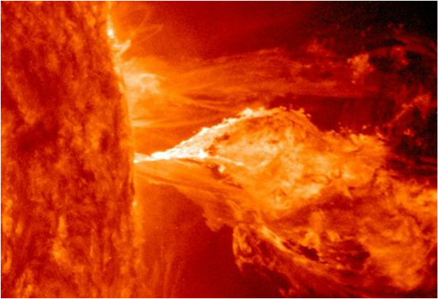 Massive solar flare. Over 1,000 earths would fit in this photo. 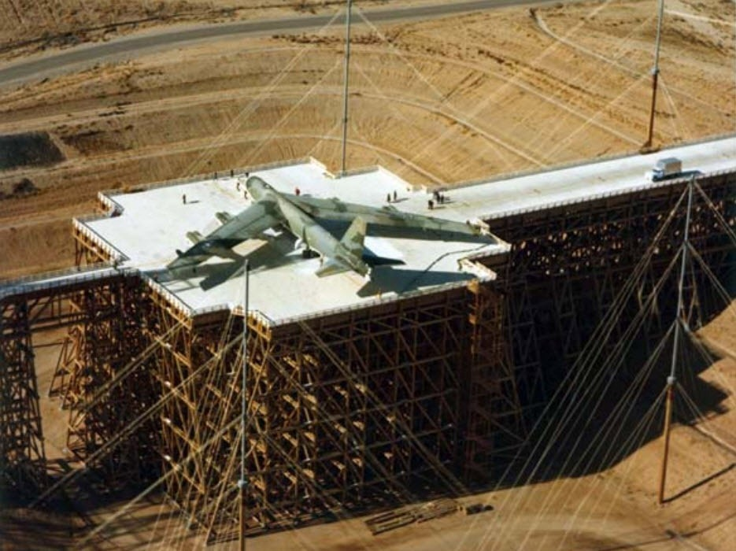Air Force EMP testing a B-52 bomber to ensure it is EMP hardened and will continue to operate in a nuclear environment.

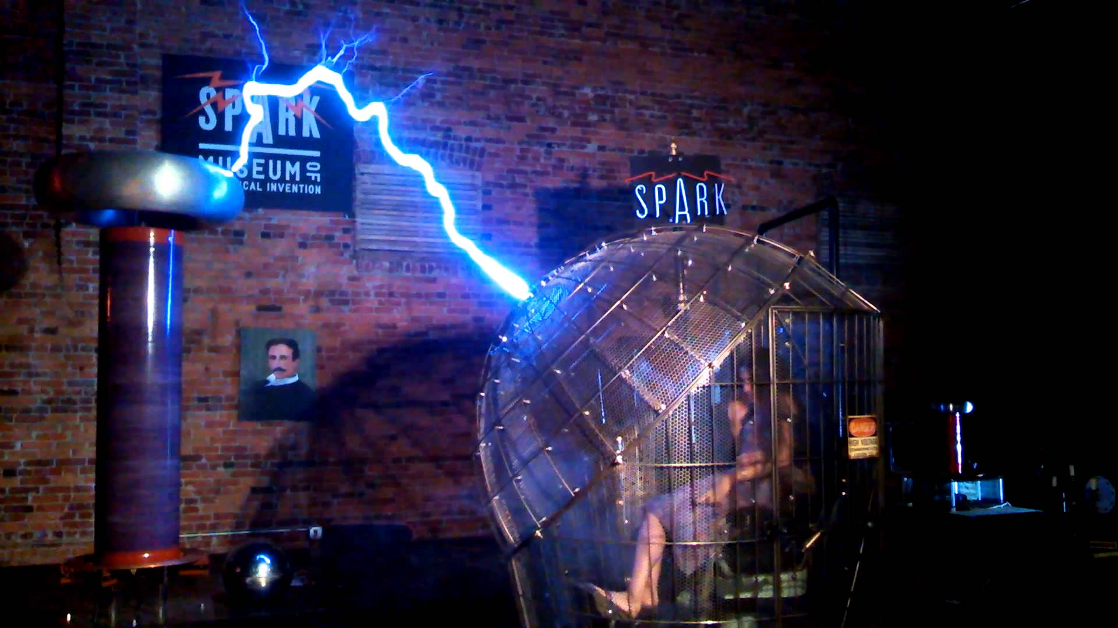

**Faraday cages** protect people or objects inside of them from electrical impacts. Similar cages can be used to protect transformers and communications centers or SCADAs. There are also other ways to protect indoor equipment that DARPA contractor Conductive Composites in Heber City, UT among others, has perfected.

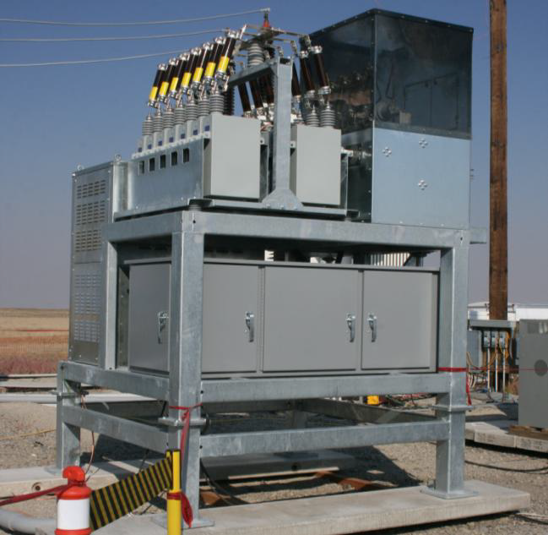

An Idaho National Labs (INL) hardened three phase transformer, protected (black cage) at a cost of $60-80,000 depending on quantity ordered. Source: Apocalypse Unknown, Pry, 2013.

We urge the DOE to partner with the DoD to protect and secure our critical electrical infrastructure so it is not such an attractive target to hackers or those planning wars with EMP weapons in mind.

*On Behalf of the Utah EMP Task Force and at your service,*

Bob McEntee, USAF Academy Graduate, Former USAF Pilot, Navigator and award winning war planner.

